**ITEM BAR CODE**

**TO START   
1.) Menu  
2.) Maintenance  
3.) Item barcodes**

Item Barcodes

Maintenance

Menu

2 1*1*

3 1*1*

1 1*1*

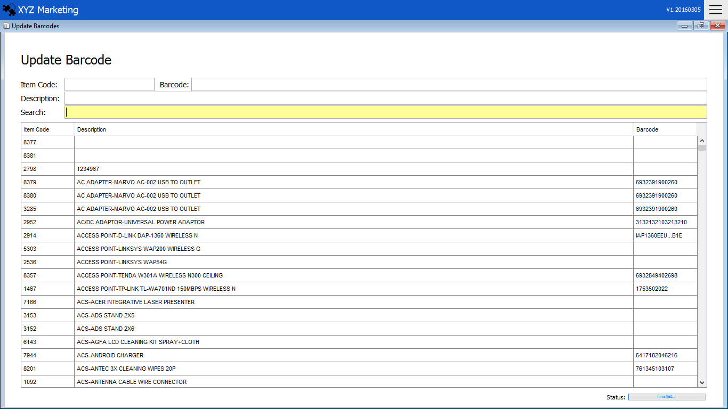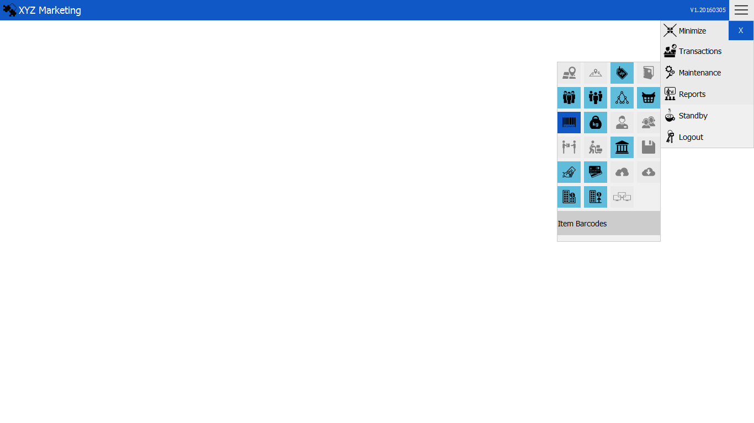

3 1*1*

Select item in the list

Search Item

1 1*1*

2 1*1*

**UPDATE ITEM BARCODES  
1.) Search item**

**2.) Select item  
3.) Input barcode**

Input Barcodes

1. **Search item**



Search the item wanted to update the barcode

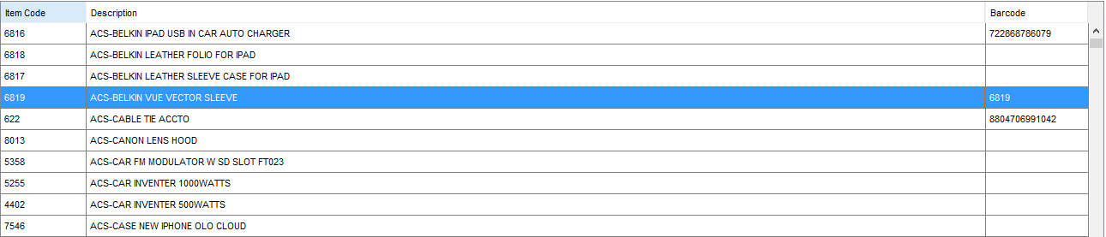**2.) Select item**

Select the item in the list and press enter to continue.

1. **Input barcode**



Input the new barcode to update and press enter to finish.